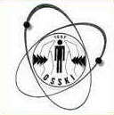
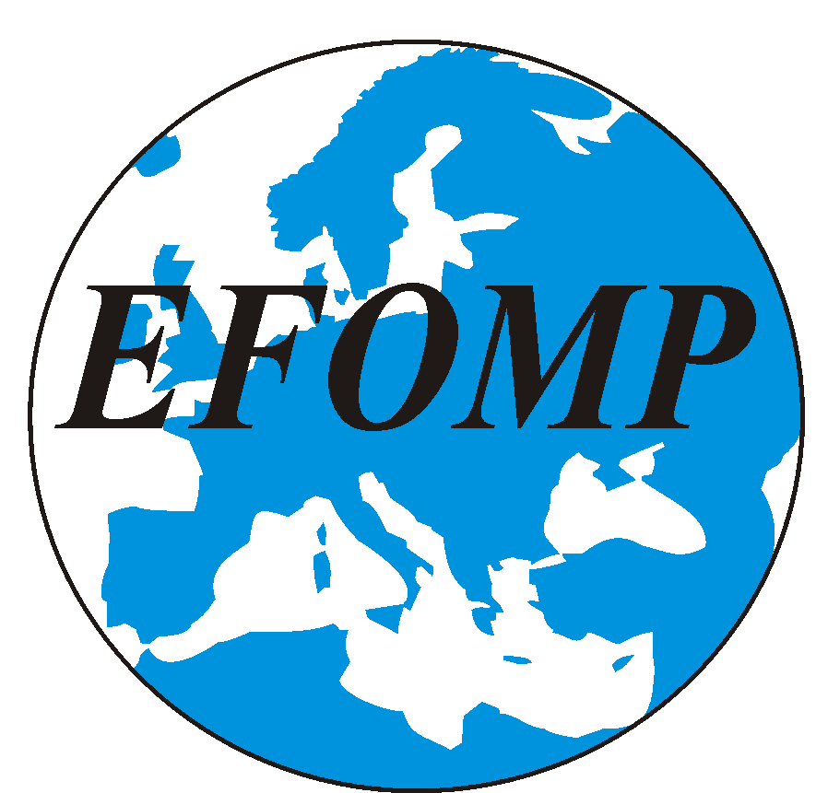

PROGRAM

First Central & Eastern European Workshop on
Quality Control, Patient Dosimetry and Radiation Protection
in Diagnostic and Interventional Radiology and Nuclear Medicine

scientifically supported
and accredited as a CPD event for medical physicists
(with a maximum of 11 hours, accreditation code: WS0001/2007)
by EFOMP

Website: http://www.osski.hu/rendez/qcworkshop/index.htm

National “Frédéric Joliot-Curie” Research Institute
for Radiobiology and Radiohygiene
1221 Budapest, XXII., Anna u. 5.
(All programmes are to be held in the library unless otherwise stated.)

Budapest, Hungary

April 25-28, 2007
April 25, Wednesday

From 13.00: Arrival, registration, coffee

Opening and Session 1: Introductory topics

Chairpersons: B. Michael Moores, Géza Sáfrány

16.00: Opening (Géza Sáfrány)
16.15: Géza Sáfrány: Activities of the 50 years old NRIRR
16.30: B. Michael Moores: Quality control in diagnostic radiology – its history and present in Europe (invited lecture)
17.30: Stelios Christofides: EFOMP – its mission and opportunities (invited lecture)

18.15: Welcome reception

April 26, Thursday

Session 2: General
Chairpersons: Stelios Christofides, Pál Zaránd

8.30: Die Entdeckung der Röntgenstrahlen – 100 Jahre danach – video (in German)
9.00: Renato Padovani: The SENTINEL project (invited lecture)
9.45: Rémy Klausz (GE, France): Digital mammography – its physical foundations, and first experiences in its quality control (invited lecture)

10.15: Coffee break
10.30: Institute visit (in small groups) – radiation sources, radiohygiene emergency car, whole-body counter, veterinary research
12.30: Lunch break

Session 3: Dosimetry in diagnostic and interventional radiology

Chairpersons: Marta Wasilewska-Radwanska, Ferenc Giczi

14.00: Ferenc Giczi, Sándor Pellet, László Ballay, Alfréda Temesi, Anna Mária Motoc, Tamás Porubszky, Géza Gáspárdy: Results of the Hungarian National Patient Dose Assessment Programme 1989-2007
14.15: Olivera Ciraj-Bjelac, Milojko Kovačević, Duško Košutić, Srpko Marković: Radiation dose levels for conventional diagnostic radiology examinations in Serbia
14.30: Leos Novak, J. Rada, O. Smejkal, I. Horakova, J. Oceansky: National study of radiation exposures of patients during X-ray diagnostic procedures in the Czech Republic
14.45: Asen Dimov, Jenia Vassileva: A pilot study of the patient doses from barium meal and barium enema examinations in Bulgaria
15.00: Denisa Nikodemová, Martina Horváthová, D. Drábová, Dušan Šalát (Slovakia): Patient and staff doses in paediatric cardiac interventional procedures
15.15: Kamil Kisielewicz, Adrian Truszkiewicz, Sebastian Wach, M. Budzanowski: Personal and environmental dosimetric measurements using TLD method in Cardiac Catheterization Laboratory (CathLab) at the Rzeszów’s Regional Hospital No. 2, Poland
15.30: Rada Borisova, Jenia Vassileva (Bulgaria): Exposure to patient and staff during interventional cardiological procedures
15.45: Summary

16.00: Coffee break

Session 4: Optimization in diagnostic radiology
Chairpersons: Jenia Vassileva, Julius Žiliukas

16.30: Valeriy Orel, N. N. Dzyatkovskay, N. A. Nikolov, A. V. Romanov (Ukraine): Computer-aided quantitative control applied to image and radiation of X-ray equipment
16.45: Olivera Ciraj-Bjelac, Milan Lončar, Dajana Veljković, Milojko Kovačević, Duško Košutić: Patient dosimetry and image quality in conventional diagnostic radiology: an experience from a local Serbian hospital
17.00: Vesna Gershan: Dose and image quality in mammography in Macedonia
17.15: Arun Chougule (India): Quality assurance of X-ray machines and patient doses during various radiological procedures
17.30: Shadrack Anthony Kiti: Assessment and evaluation of personnel dose of radiation workers using thermoluminescence dosimetry in Nairobi, Kenya
17.45: Summary

19.15: Conference dinner (Hotel Ventura)

April 27, Friday

Session 5: Quality control and testing in diagnostic radiology
Chairpersons: Marta Wasilewska-Radwanska, Tamás Porubszky

8.45: Gendrutis Morkūnas, Julius Žiliukas (Lithuania): From quality control to quality systems in X-ray radiology – step by step approach
9.00: Jenia Vassileva: Quality control in diagnostic radiology in Bulgaria – national legislation, implementation, problems
9.15: Marta Wasilewska-Radwanska, Edward Araszkiewicz, Adam Ploszaj, Anna Cepiga: Evaluation of quality assurance for X-ray mammography equipment in some medical departments of Malopolska District in Poland
9.30: Martina Horváthová, Denisa Nikodemová: Quality control of mammography departments in Slovakia
9.45: Asen Dimov, Jenia Vassileva (Bulgaria): Commissioning of two image intensifier fluoroscopy units
10.00: Tamás Porubszky, Sándor Pellet, László Ballay, Csaba Váradi, Olivér Turák, Ferenc Giczi: Five years experience of the Radiohygiene Department Laboratory of NRIRR in acceptance testing of diagnostic radiology equipment in Hungary
10.15: Tamás Porubszky, Sándor Pellet, Ferenc Giczi, Tibor Fekete (Hungary): The X-ray Status Testing Laboratory
10.30: Tamás Porubszky, Sándor Pellet, László Ballay, Olivér Turák, Csaba Váradi: Conformance testing of diagnostic radiology equipment at the Radiohygiene Department Laboratory of NRIRR
10.45: Summary

11.00 Coffee break

Session 6: Radiation protection, radiation biology,
regulation, standardization, professional matters
Chairpersons: Denisa Nikodemová, János Barsai

11.20: Olivér Turák, László Ballay, Sándor Pellet, Kamilla Ozoray: Regulation and organizatory network of radiation protection in Hungary
11.35: Tamás Porubszky, János Barsai (Hungary): Changes in IEC standards related to diagnostic radiology
11.50: Pál Zaránd: Situation of medical physics in Hungary
12.05: Liubov Koretskaya, Ion Bahnarel, Natalia Cechirlan: Medical and biological aspects of the Chernobyl nuclear accident influence on the population of Republic of Moldova
12.20: Summary

12.30: Lunch break

Session 7a: Computed tomography and nuclear medicine
Chairperson: Teréz Séra

14.00: Lajos Balogh, Réka Király, András Polyák, Domokos Máthé, Gábor Andócs, Zoltán Bozóky, Győző Jánoki (Hungary): Standard bioassay based human internal dosimetry data calculations using MIRDOSE and OLINDA programs – Supportive biological dosimetrical data from veterinary nuclear medicine patients
14.15: Augusto Giussani (Germany): Individual optimization of therapeutic applications and dosimetry of radiopharmaceuticals with the help of compartmental analysis
14.30: Marta Wasilewska-Radwanska, Artur Stepien, Katarzyna Natkaniec (Poland): Patient and staff dose optimisation in nuclear medicine diagnosis methods
14.45: Goran Vuleta: Quality control in Department of nuclear medicine, Clinical Centre Banja Luka, RS, Bosnia and Herzegovina
15.00: Desislav Stoyanov, Jenia Vassileva: Quality control protocol for computed tomography systems in Bulgaria
15.15: Sasan Esmaili, Maryam Khalilpour (Iran): Estimation of skin, organ and effective doses of patients who undertake head CT scan in 4 medical radiography departments (Poster discussion)
15.20: Summary

Session 7b (alternative): Visit at Radiological Department of the
National Institute of Oncology
Hosts: Mária Gődény, head of Department, Viktor Zömbik, X-ray engineer

13.15: Departure from NRIRR

16.00: Coffee break

19.00: Concert performance (Verdi: The troubadour) (Bartók Béla National Concert Hall in the new Palace of Arts)

April 28, Saturday

Session 8: Devices for X-ray QC from Europe
(Manufacturers’ presentations)
Chairpersons: Sándor Pellet, Tamás Porubszky

8.30: Olga Fröscher (PTW Freiburg, Germany)
9.15: Cornelia Lipfert (Scanditronix-Wellhöfer, Germany)
10.00: Coffee break
10.20: Tomas Unfors (Unfors Instruments, Sweden)
11.05: Sara Börjesson (RTI Electronics AB, Sweden)
11.50: Discussion

12.20: Session 9: Roundtable (Moderator: Sándor Pellet)
13.20: Closing of the workshop

13.30: Lunch

15.00 to 18.00: Sightseeing with bus
Departure from Hotel Ventura

April 29, Sunday

8.00: Excursion with bus and English language guide into the Danube Bend (Esztergom: Cathedral, Treasury; Visegrád: Upper castle; lunch at Renaissance Restaurant; Szentendre: sightseeing walk, exhibition of ceramist Margit Kovács [1902-1977]). Departure from Hotel Ventura
Arrival to Hotel Ventura at approx. 18.00.

