COMPUTER-AIDED QUANTITATIVE CONTROL APPLIED
TO IMAGE AND RADIATION OF X-RAY EQUIPMENT
Orel V.E.,* Dzyatkovskaya N.N., Nikolov N.A.,
Romanov A.V., Morozoff A.B.
Medical Physics and Bioengineering Department
Institute of Oncology of Academy of Medical Sciences, 33/43
Lomonosov str., 02033, Kyiv, Ukraine

*E-mail: v-orel@i.com.ua

INTRODUCTION
One of the most significant occurring in medical imaging is the transition from film and video based analog to digital imaging. While analog images are still required for human viewing there are significant advantages in having images in a digital form at other stages of the imaging process. The advantages come from the many functions which can only be performed, better, with digitized images. Using of digital X-ray equipment allows to limit the radiation effect on patients and to improve the quality of medical images [1].The modern digital images visualized on the monitors of X-ray apparatus are widely adopted for the preparation of tumor diagnostics. Regret in Ukrainian cancer hospital we have a limited number of x-ray equipment with digital imaging.
The problem of visualization is limited by non-adequate image perception connected with psychophysics characteristics of human eye and engineering parameters of device. Digital images have very significant characteristic which contribute to quantitative control of X-ray images. Because they are in digital form they can be processed by digital computer [2]. During recent years, several aspects of nonlinear dynamics (chaos theory) have been explored for quantitative control of medical images [3].
The aim of this presentation the comparative research of film and digital x-ray equipment was performed by computer-aided quantitative control with the help nonlinear (chaos) theory
MATERIALS AND METHODS
Equipments
Film X-ray equipment RUM-20М (Mosrentgen, Russian) and digital X-ray equipment Multix Pro (Siemens, Germany) were compared. For radiation control of micro-roentgen radiation the monitor RM-60 (Aware Electronix, USA) connected with computer was used. The quality of medical images was estimated with an aid of test objects: STEP, TRG, TRS and PP (Ukraine). We used for comparative analysis of the photo camera Lumix DMC-FZ10 (Panasonic, Japan).
Parameters of equipment: high voltage – 76 кV; current strength – 100 mА; time exposition – 0,06 second; exposition dose on film cassette of X-ray equipment RUM-20М – 21,9 mR; exposition dose on detectors of X-ray equipment digital X-ray equipment Multix Pro 2,85 mR.
Analysis of Digital Imaging
The X-ray images were tested by evaluation of brightness level, the contours asymmetry and quantitative heterogeneous of the structure. The proposed algorithm and software for estimation of spatial chaos in digital medical image is based on calculation of the spread parameters and autocorrelation function by Moran's.
The flowchart of algorithm for the evaluation of quality X-ray image is developed (Fig. 1).
Fig.1. The flowchart of algorithm for evaluation of quality x-ray image
Visualization of X-ray Image

Scope of Selection
Statistical Analysis
Contour
Asymmetry
Control of
Brightness Level
Heterogeneity of the Structure
Estimation
of Spread Parameter
Estimation of Moran Autocorrelation
Conclusion
Estimation
of Spread Parameter
The heterogeneity we estimated by equation
G = 1 – r, | (1)
Moran's r is defined as follows
, | (2)
where n is the number of pixels in X-ray image, xi is intensity of pixel m, is the mean intensity, and wi is a distance-based weight which is the inverse distance between locations i and j (1/dij)
Spread parameter S(Φ) of phase map Φ = {(x, y)| x = f (t), y = f (t+τ), t0 ≤ t ≤ tN} defined as
(3)
where , , , , τ is temporal lag.
The spread parameter is approximately the area of the figure outlined with the envelope of the phase trajectory [4].

RESULTS
Test object step-wedge analysis
We transmitted of test object step-wedge analysis (Fig.2). Equipment of Multix Pro was more effective than RUM-20.
 |  | RUM-20
Spread parameter = 20.89 a.u. | Heterogeneity = 0.176 a.u.
 |  | Multix Pro
Spread parameter 25.65 a.u. | Heterogeneity 0.299 a.u.
Fig.2. Test object step-wedge
Test object TRS analysis
You can see from comparative analysis of photo and X-ray images (Fig.3) that RUM-20 had adjusted was worse than Multix Pro.
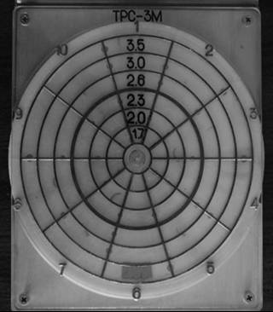 | 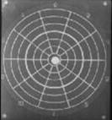 | 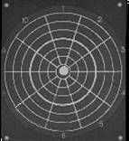
Digital photo image | X-ray image  RUM-20 | X-ray image  Multix Pro

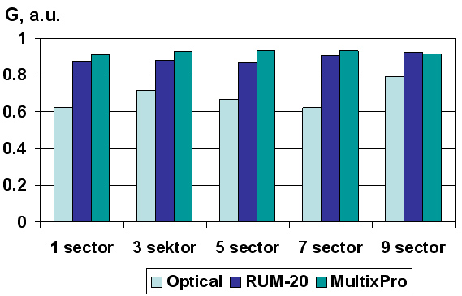 | 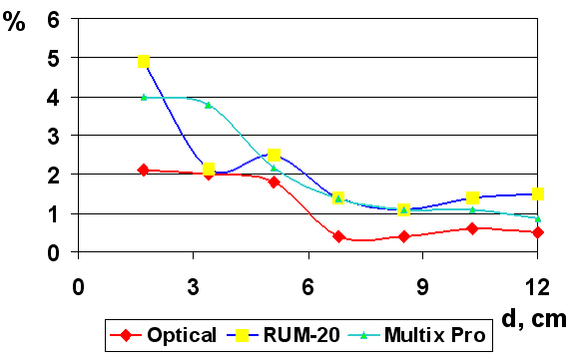
Heterogeneity | Asymmetry
Fig.3. Test object TRS
Spatial resolution analysis by test object PP
Spatial resolution analysis was 2.2 lp/mm for RUM-20 and 3.1lp/mm for Multix Pro .

CONCLUSION
- Developed computer-aided quantitative control of X-ray equipment with the help nonlinear (chaos) theory.
- Comparative experimental study using computer-aided quantitative control of showed that x-ray diagnostic digital image system Multix Pro has higher value of the scale characteristics in comparison with film image system to RUM-20M.
- Performed analysis by means of computer-aided quantitative control spoke about the necessity to upgrade the X-ray instrumentation in accordance with European standards.

REFERENCES
1. Sprawls P. (1997). Digital Imaging Concepts and Application. In G.D. Frey, P. Sprawls (Eds.), The expanding role of medical physics in diagnostic imaging (pp.381–405). Madison, Wisconsin. Advanced Medical Publishing.
2. Hendee, W. R., Rifenour, E. R. (1992). Medical Imaging Physics. Baltimore. Mosby Year Book.
3. Orel V., Kozarenko T., Galachin K., Romanov A., Morozoff A. (2007). Nonlinear Analysis of Digital Images and Doppler Measurements for Trophoblastic Tumor. Nonlinear Dynamics, Psychology, and Life Sciences (in press).
4. Orel, V. E., Romanov, A. V., Dzyatkovskaya, N. N., Mel’nik, Yu. I. (2002). The device and algorithm for estimation of the mechanoemission chaos in blood of patients with gastric cancer. Medical Engineering and Physics, 24, 365–371.

